**ENHANCEMENT IN CAREER FINDER**

**A MINI PROJECT REPORT**

Submitted by

**POOARASU S - 810020104058**

**VIGNESHWARAN V - 810020104083**



**DEPARTMENT OF COMPUTER SCIENCE AND ENGINEERING**

**ANNA UNIVERSITY, THIRUCHIRAPPALLI– 620024**

**MAY 2023**

**UNIVERSITY COLLEGE OF ENGINEERING BIT CAMPUS,**

**ANNA UNIVERSITY, TIRUCHIRAPPALLI – 620024**

**DEPARTMENT OF COMPUTER SCIENCE AND ENGINEERING**



**BONAFIDE CERTIFICATE**

This is to certify that this Mini Project report on **“Enhancement in career finder”** is the bonafide work of **Pooarasu S (810020104058) and Vigneshwaran V (81020104083)** have satisfactorily completed the course of **CS8611 MINI PROJECT** for the **VI semester, B.E COMPUTER SCIENCE AND ENGINEERING** during the year 2022-2023.

**Guide Faculty In-charge Head of the Department**

**Submitted for the university practical Examination held on …………………**

**Internal Examiner External Examiner**

**ABSTRACT**

The purpose of this project is to enhance a job portal website by adding additional features that will improve the user experience and increase the likelihood of successful job matches. This project has added the features including a personality assessment test for job seekers, a skill-based search function for employer’s usage. This website adds the features for simplifying the process of setting up interviews, for reducing scheduling conflicts and improving the overall efficiency of the virtual hiring process. This website integrates resume builder and blogger functionality. Resume builder feature helps to present job seeker’s qualification and in securing an interview. Blogger helps to share employee’s interview experience and company reviews with the new job seekers. This website integrates the feature of job application tracking systems which helps job seekers to know the application status such as whether application is forwarded to a correct employer or not. Because of these features this website will attract more users and increase its value as a resource for job seekers and employers alike.

**Keywords:** Job portal, Recruiters, Job- Seekers, Fraud, Internet, Internet users

**TABLE OF CONTENTS**

|  |  |  |
| --- | --- | --- |
| **CHAPTER** | **TITLE** | **PAGE NO** |
|  | **ABSTRACT** | III |
|  | **LIST OF FIGURES** | VI |
|  | **LIST OF ABBREVIATIONS** | VI |
| **1** | **INTRODUCTION** | 1 |
|  | 1.1 Overview | 1 |
|  | 1.2 Objectives | 2 |
|  | 1.3 Motivation | 2 |
|  | 1.4 Literature Survey | 3 |
| **2** | **SYSTEM MODELING** | 5 |
|  | 2.1 Data Flow Diagram | 5 |
|  | 2.1.1 LEVEL-0 DFD | 5 |
|  | 2.1.2 LEVEL-1 DFD | 6 |
|  | 2.1.3 System architecture | 7 |
|  | 2.2 Hardware & Software Specifications | 8 |
|  | 2.2.1 Hardware Specification | 8 |
|  | 2.2.2 Software Specification | 9 |
|  | 2.3 Contribution | 10 |

|  |  |  |
| --- | --- | --- |
| **3** | **MAIN THEME OF PROJECT WORK** | **12** |
|  | 3.1 Implementation Phases | 12 |
|  | 3.2 Employee Login | 12 |
|  | 3.3 Employer Login | 14 |
|  | 3.4 Resume Generator | 14 |
|  | 3.5 Blog Post | 16 |
|  | 3.6 Database Connectivity | 17 |
| **4** | **PERFORMANCE** | 18 |
| **5** | **CONCLUSION** | 19 |
|  | 5.1 Limitations of the Existing system | 19 |
|  | 5.2 Further Enhancements | 20 |
|  |  |  |
|  | **APPENDICES** | 21 |
|  |  |  |
|  | **REFERENCES** | 26 |

**LIST OF FIGURES**

|  |  |  |
| --- | --- | --- |
| **FIGURE** | **FIGURE NAME** | **PAGE NO** |
| Figure 2.1 | DFD LEVEL 0 | 5 |
| Figure 2.2 | DFD LEVEL 1 | 6 |
| Figure 2.3 | System Architecture | 8 |
| Figure 3.1 | Login Page | 13 |
| Figure 3.2 | Featured Jobs Page | 13 |
| Figure 3.3 | Post Jobs Page | 14 |
| Figure 3.4 &  Figure 3.5 | Resume Page | 15 |
| Figure 3.6 | Articles Page | 16 |
| Figure 3.7 | Mongodb Database Page | 17 |
| Figure 4.1 | Performance | 18 |

# LIST OF ABBREVIATIONS

**ABBREVIATION DESCRIPTION**

HTML Hyper Text Markup Language

EJS Embedded JavaScript

CSS Cascading Style Sheet

DFD Data Flow Diagram

URL Uniform Resource Locator

**CHAPTER-1**

1. **INTRODUCTION**

Job portal is an online platform designed to connect job seekers with various industries to provide the suitable employment opportunities. In addition to standard job listing this project has incorporated several additional features. This project offers a comprehensive candidate profile management system that allows job seekers to showcase their qualifications, work experience, education, and other relevant information to potential employers. This feature enables employers to assess candidate suitability quickly and make informed hiring decisions. The feature for monitoring job applications will assist job searchers in keeping track of their applications' status. This technology would provide efficient and organized tracking of job applications at various companies.

**1.1 OVERVIEW**

There are a number of additional features that may be added to a job portal in addition to its standard capabilities to improve user experience and benefit both employers and job searchers. Applicant tracking system, resume generator, and professional blog creation are a few of these extra features.

**1.2 OBJECTIVES OF THE STUDY**

1. To study the various recruitment processes.
2. To study various limitations in the existing job portal websites.
3. To study the difficulties faced by job-finder from the point of finding jobs.
4. To study the difficulties faced by employer from the point of providing jobs.

**1.3 MOTIVATION**

In addition to the basic features of a job portal, there are several additional features that can be incorporated to enhance the user experience and provide value to both job seekers and employers. Some of these additional features include: Application tracking system, Resume builder, creation of blog for professionals.

**1.4 LITERATURE REVIEW:**

**1.4.1 The Role of E-Recruitment in Attracting Potential Candidates**

**Evidence from Fresh Graduate Job Seekers**

**Rakholiya and Gupta (2013)** studied the applicant's perception toward the usefulness of e-recruitment websites, processing time and cost of e-recruitment, specific factors while selecting a job through e-recruitment. Research methodology was descriptive and analytical: research design was qualitative and quantitative, sample size for this research was taken 100, convenience sampling method was used. This study focused on the e-recruitment on the individual’s perception and satisfaction. On the basis of individual understanding engineering practices provided online job seekers need to deliver valuable information, easy & enjoyable web-based recruitment to job seekers.

**1.4.2 Impact of e-recruitment and job-seekers perception on intention to pursue the jobs**

**Khan et al. (2013)** explored the significance of e-recruitment practices and investigated the relationship between the job seekers perception, recruitment sources and intention to pursue the job. 257 respondents were chosen for the study. The present study established that internet is the most popular recruitment source to search the jobs and to study the job seekers perceptions.

**1.4.3 E-Recruitment: A Conceptual Study. International Journal of Applied Research**

**Kaur (2015)** focused on the criteria for effective e-recruitment, methods, trends, benefits & drawbacks of the e-recruitment. The research methodology was exploratory and qualitative. Secondary sources of data were taken from various journals, articles, and research papers. The author suggested traditional method should not be replaced by the online recruitment fully, it should supplement and cover the traditional method and recruitment process will be faster and time saving. In the recruitment process adopted by companies the credit goes to the value, efficacy and ease of using career site.

**1.4.4 Factors affecting e-recruitment**

**Ahlawat and Sangeeta (2016)** explored the different sources of e-recruitment in the organization like ease of use for the organization, increasing the speed to hire, keeping ahead of competitors, cost savings, to ease of use for candidate, to provide large candidate pool. This study was a set of comprehensive overviews of e-recruitment, also to see the challenges and benefits of using online technologies. The organization used online recruitment system to track and manage candidate’s application, that gives significant benefits in the term of cost and capability, efficiency to monitor on recruitment activities.

**1.4.5 Effect of E-Recruitment on Recruitment**

**Malhotra & Sharma (2016)** compared with traditional recruitment process with e-recruitment advantages and disadvantages, changed in recruitment practices and strategies causes of e-recruitment tools and analysed the challenges and opportunities for both organizations and employees using e-recruitment. The study found that traditional method not be replaced by e-recruitment. It should complement. It is a fast process. In the modern time job portals are the most popular source of e-recruitment because commercial websites provide a platform for employers to meet the prospective employees.

**CHAPTER 2**

**2. SYSTEM MODELLING**

**2.1 DFD LEVEL 0 & LEVEL 1**

**2.1.1 DFD 0**

A data flow diagram (DFD) maps out the flow of information for any process or system. It uses defined symbols like rectangles, circles and arrows, plus short text labels, to show data inputs, outputs, storage points and the routes between each destination. They can be used to analyse an existing system or model a new one. Like all the best diagrams and charts, a DFD can often visually “say” things that would be hard to explain in words, and they work for both technical and nontechnical audiences, from developer to CEO. The DFD level 0 of this project is discussed in this chapter. DFD Level 0 is also called a Context Diagram. It’s a basic overview of the whole system or process being analysed or modelled.

Employee

Employer

Jobs

**Figure 2.1**

In DFD level 0 shows there are two logins. One is employee login and other is employer login. In employee login, the job seeker can create his profile and generate a resume. Then he can search for jobs. The employee can write blogs, and the job seeker can search the blogs. In employer login, the employer can post jobs with description. Refer figure 2.1.

**2.1.2 DFD 1**

DFD Level 1 is a general overview, but it goes into more detail than a context diagram or DFD 0. In level 1 DFD, the single process node from the context diagram is broken down into sub-processes. As these processes are added, the diagram will need additional data flows and data stores to link them together.

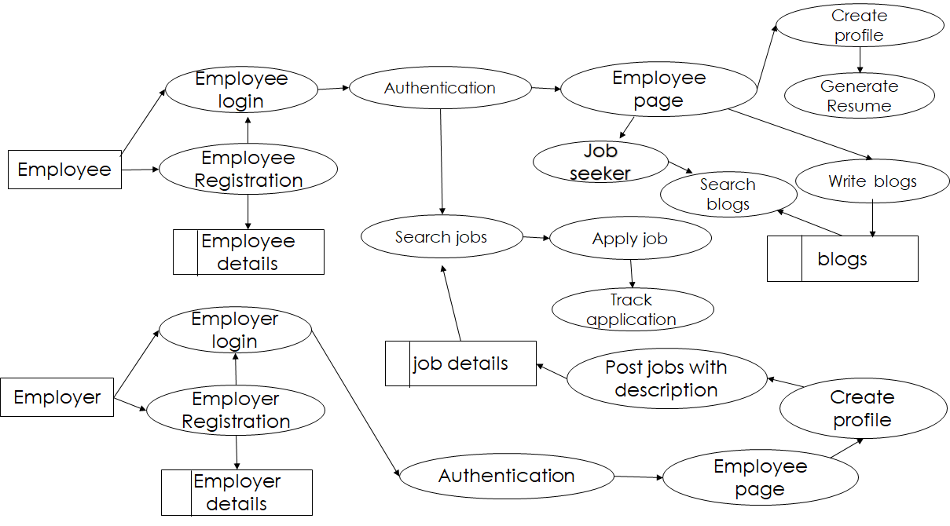

**Figure 2.2**

In DFD level 1 shows the detailed view of employer login and employee login. In employee login, the employee should have an account or he should create an account with strong user name and password. The employee login details are stored in database. Before login, system needs to authenticate the valid user or not. In employee page has menu bar. It contains create profile, search jobs, and blogs. After creating the profile, the employee can generate his resume. The employee details are stored in database. The job seeker can search and apply the job. The job seeker can track the status of the applied job. The employee can write blogs, and the job seeker can search the blogs. In employer login, the employer should have an account or he should create an account with strong user name and password. The employer login details are stored in database. Before login, system needs to authenticate the valid user or not. The employer page has created profile and post jobs. The employer should his create profile before posting the job. Before posting the job, employer should provide the job description. The job details are stored in database. Refer figure 2.2.

**2.1.3 System architecture**

An architectural diagram is a visual representation that maps out the physical implementation for components of a software system. It shows the general structure of the software system and the associations, limitations, and boundaries between each element.

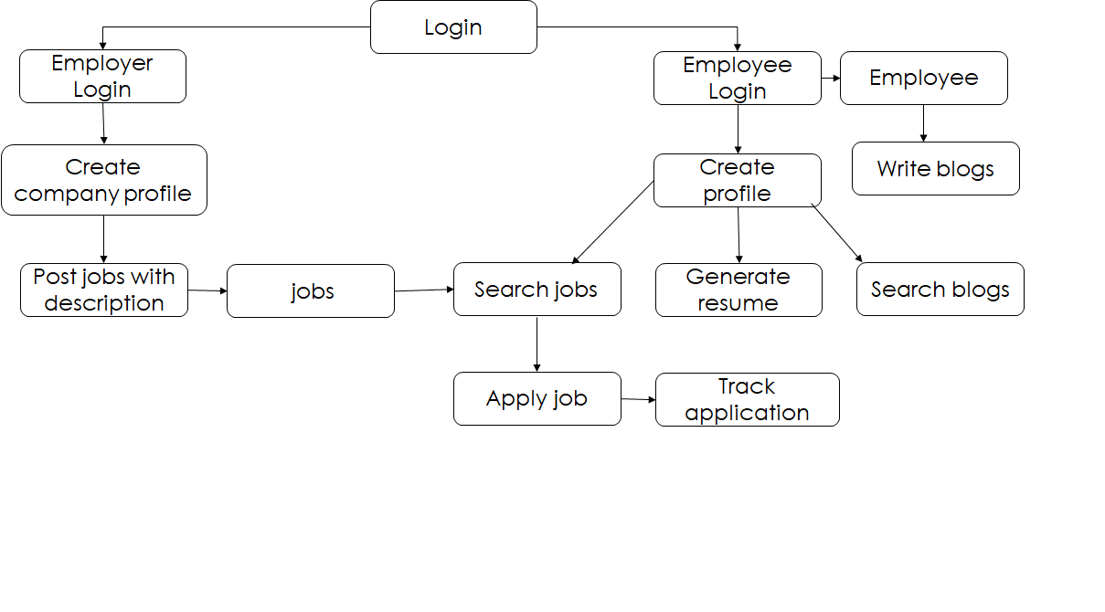

**Figure 2.3**

The diagram shows there is two logins. One is employee login and other is employer login. In employee login, the job seeker can create his profile and generate a resume. Then he can search for jobs. The employee can write blogs, and the job seeker can search the blogs. In employer login, the employer should his create profile. Before posting the job, employer should provide the job description. Refer figure 2.3.

**2.2 Hardware and Software Specifications**

**2.2.1 Hardware Specification**

The following are the hardware requirement of the system that the design can be implemented upon.

**Minimum Specification**

* Hard disk space of 512 Megabytes.
* Intel i3 or Ryzen 3 processor.
* RAM of 2 Gigabytes.

**Recommended Specification**

* Hard disk space 1024 Megabytes or more.
* Intel i5 or Ryzen 5 processor.
* RAM of 4 Gigabytes or more.

**2.2.2 Software Specification**

The following are the software requirement of the system that the design can be implemented upon.

* Operating System Either Windows (or) Linux.
* **Frontend Languages:**

HTML:

The HTML markup language is used to create the structure of the web page.

CSS:

The CSS stylesheets are used to design the web pages

EJS:

The EJS template engine is used create components needed in this project.

* **Backend languages:**

**Node JS:**

In backend, the NODE JS framework is used. Packages like express, axios are used to send request or response and connect the database.

**Cloud Database: MongoDB Atlas**

MongoDB Atlas is a cloud database used in this project.

**2.3 Contribution**

810020104058-Pooarasu S

**Documentation**

Project documentation is the process of recording the key project details and producing the documents that are required to implement it successfully. The project documentation tool should Be easily editable even by non-technical users, ideally, in real time. **Microsoft word** tool is used to edit and create the document. Its’ is very comfortable to use.

**Application tracking system**

Job application tracking system which helps job seekers to know the application status such as whether application is forwarded to a correct employer or not.

**Backend**

In backend, the NODE JS framework is used. In NODE JS, the middleware functions are used to authentication the login form. Packages like express, are used to send request or response and connect the database.

**MongoDB Atlas**

MongoDB Atlas is a cloud database used in this project. The database is accessed by connection string URL.

**Resume generator**

Deciding on the design and layout of the resume, including font, colors, and formatting. Using CSS or a CSS framework, such as Bootstrap, to create the layout and styling of the resume. Create a download button that generates a PDF of the resume based on the user's information

810020104083-Vigneshwaran V

**Frontend**

**UI/UX**

Using HTML, CSS, EJS (Embedded JavaScript) to create all the pages in this project. Embedded JavaScript is a template engine to render data from backend. Creating the login system, Employer login page and Employee login page.

**Blog**

Deciding on the design and layout of the blog, including font, colors, and formatting. Creating a component for each section of the blog, such as Header, Footer, Blog Post, Sidebar, etc. Implementing a commenting system that allows users to comment on blog posts.

**CHAPTER 3**

**3. MAIN THEME OF PROJECT WORK**

**3.1: Implementation Phases**

The development and implementation of the project is categorized into Four phases:

* Employee Login
* Employer Login
* Resume Generator
* Blog Post
* Database Connectivity

**3.2: Employee Login**

In order to access the system, the employee should have an account. If the employee does not have an account, he or she should create one with a strong username and password. The login details of the employee are then stored in a database for future reference. Before granting access to the system, the system needs to authenticate the validity of the user's login details. This is done by comparing the login details provided by the user during login with the ones stored in the database. Only if the user's login details are found to be valid will the system grant access to the employee page. The employee page contains a menu bar that provides access to different features of the system. The menu bar typically contains options such as a resume generator, job listings, and blog posts. These options are implemented using a template engine called Embedded JavaScript (EJS). EJS is a popular template engine used to display data that is stored in a MongoDB database. This allows the employee to view and interact with the system's data in a user-friendly. manner. Refer figure 3.1 and 3.2.

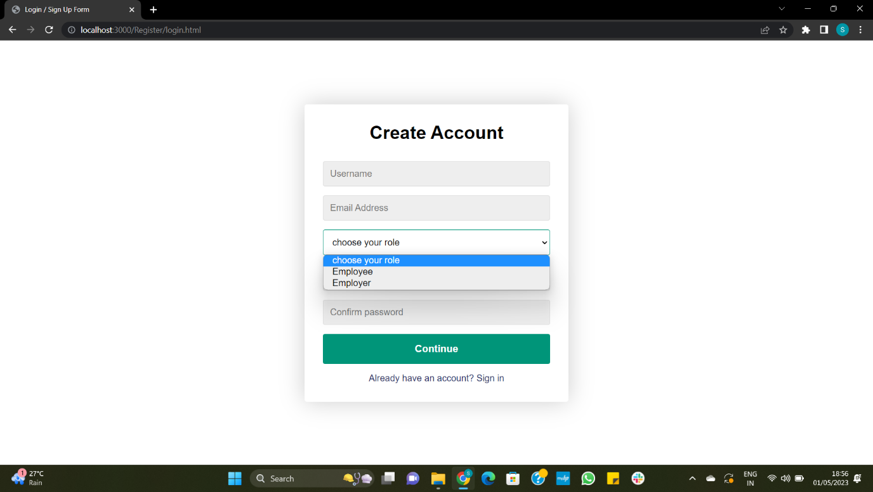

**Figure 3.1**

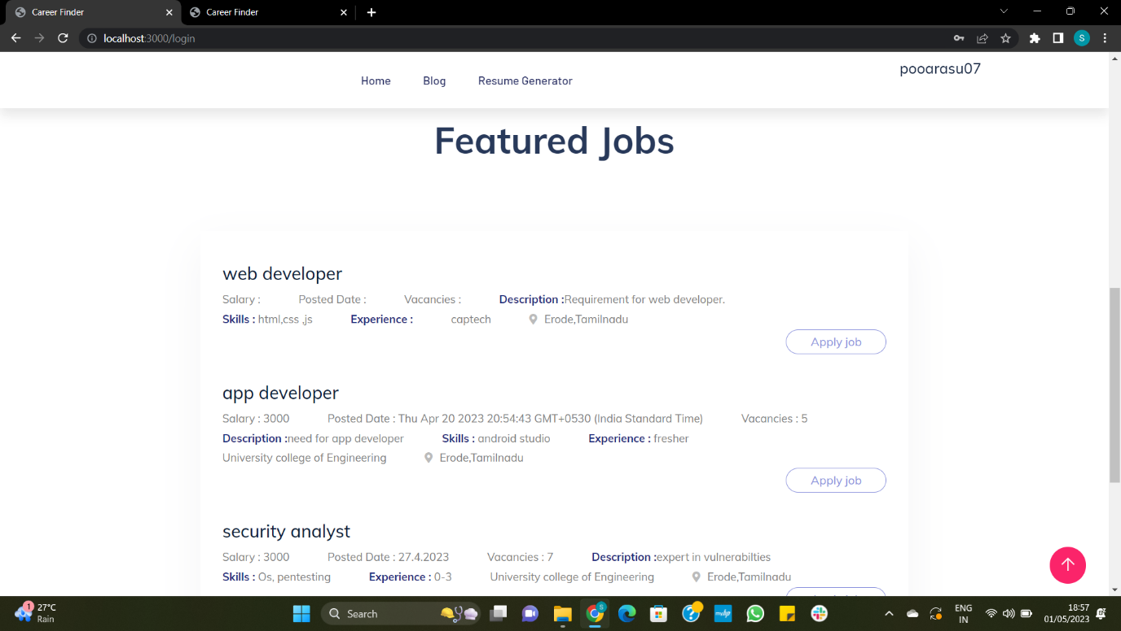

**Figure 3.2**

**3.3 Employer Login**

The employer should his create profile before posting the job. Before posting the job, employer should provide the job description. It contains the job role, job description, required skill, salary, vacancy, experience, company name, address, state. The job details are stored in database. Embedded JavaScript (EJS) is a template engine used to display the data that is stored in the MongoDB database. The stored jobs are rendered in the employee login page. Refer figure 3.3.

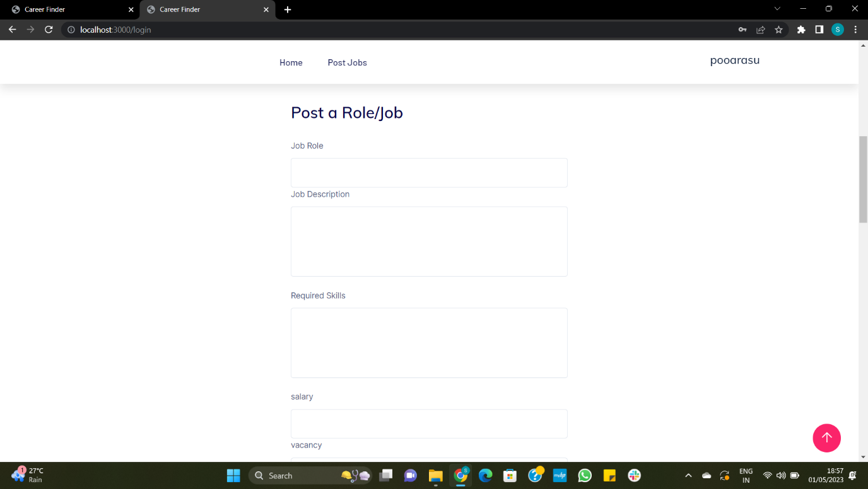

**Figure 3.2.3**

**3.4 Resume Generator**

When the employee enters profile details like personal details, qualifications, skills, and experience. There are two HTML pages. One is to get data from the form, and another is a resume template used to insert the data from the HTML form. After entering the details, the data is fetched into the resume template and generated as a pdf. Refer figure 3.4 and 3.5

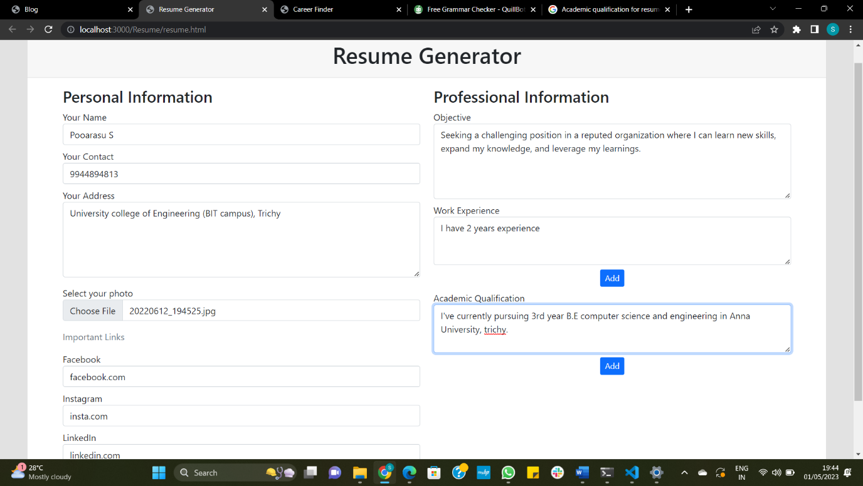

**Figure 3.4**

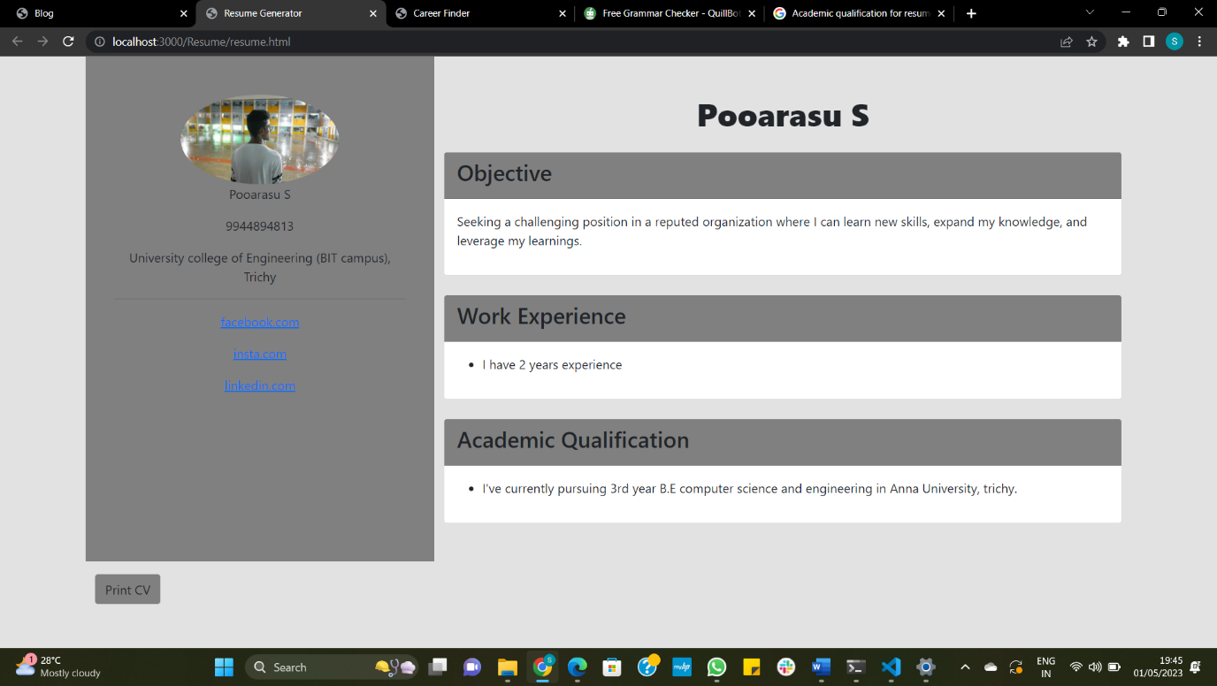

**Figure 3.5**

**3.5 Blog Post**

The blog helps to share the work experience of the previously selected candidates. It works like a CRUD application in which an employee has to create, update, read, and delete the blog. Refer figure 3.6.

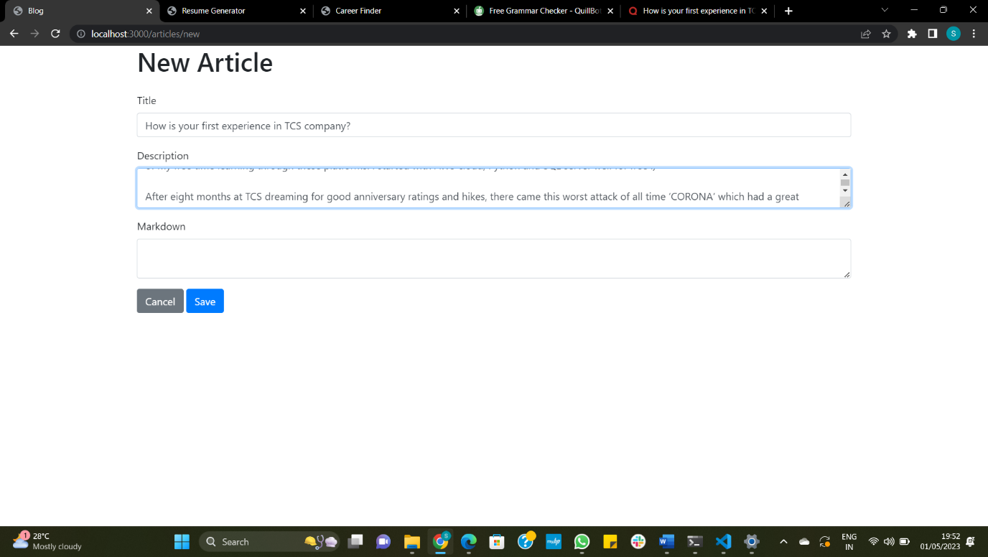

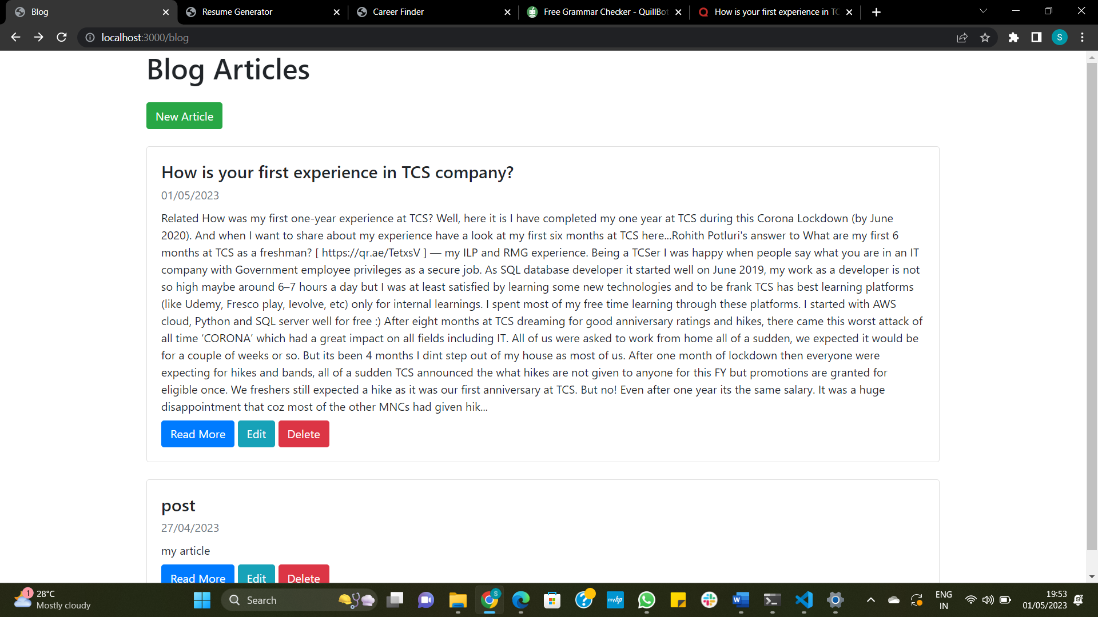

**Figure 3.6**

**3.6 Database Connectivity**

In this project, the choice of database was MongoDB Atlas, which is a cloud-based database service that is designed to provide a highly available and scalable platform for modern web applications. The project uses Node.js as the backend server to communicate with the database. To access the database, the project uses a connection string URL, which is a standard way to connect to a MongoDB database. The connection string URL contains important information such as the database name, server address, and authentication credentials. This allows the project to securely connect to the database and perform operations such as reading and writing data. Refer 3.2.7

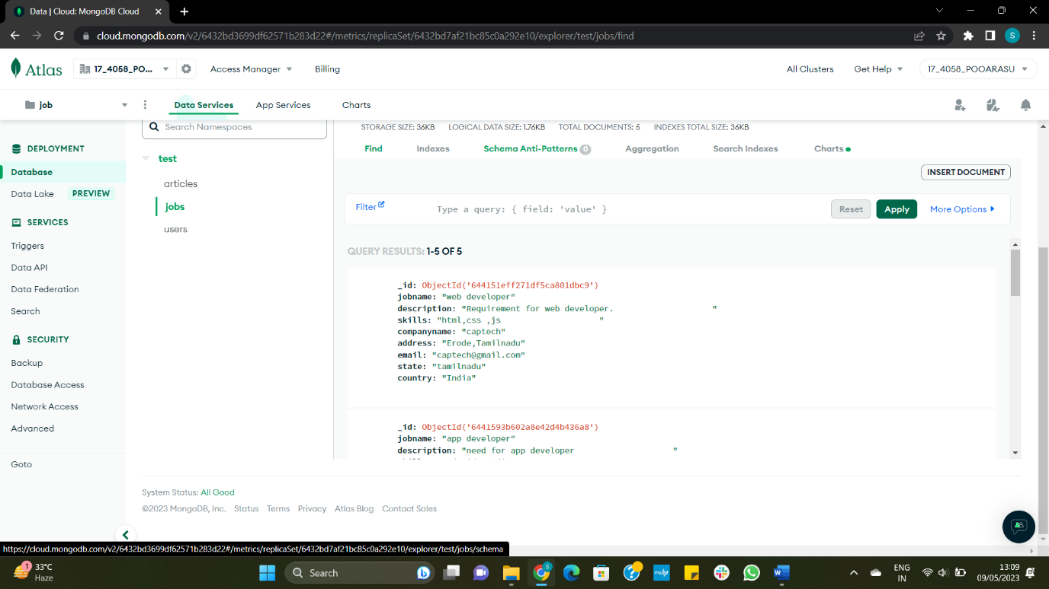

**Figure 3.7**

**CHAPTER 4**

**4. PERFORMANCE**

Proper performance monitoring is critical for delivering an effective web application to the user. Without monitoring, it's difficult to understand how well the application is performing, identify areas for improvement, and ensure that the application meets performance standards. Lighthouse is an open-source, automated tool that can help with performance analysis. It can be used to audit any web page, public or requiring authentication, and has built-in audits for various performance-related factors, such as performance, accessibility, progressive web apps, SEO, and more. The tool can be run from within the Chrome DevTools, via the command line, or as a Node module. Using Lighthouse, developers can quickly and easily identify areas of their application that may be slowing down performance or not meeting best practices for web development. This can save developers a significant amount of time and effort compared to manually identifying and addressing issues. Refer figure 4.1.

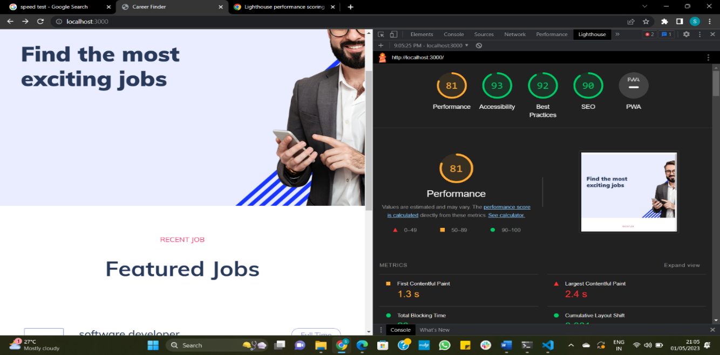

**Figure 4.1**

**CHAPTER 5**

1. **CONCLUSION**

This project describes the work on the title **Enhancement in career Finder** in an effective manner. Performance measure of this project work is obtained as 81% with the help of lighthouse software tool. The web page runs without any error and all the modules are well tested. It is an online platform designed to connect job seekers with various industries to provide the suitable employment opportunities. In addition to standard job listing feature this project has incorporated several additional features. There are two logins. One is employee login and other is employer login. In employee login, the employee/job seeker has to create his profile. After creating the profile, he has to search for jobs, Search/write blogs and generate his resume.

**5.1 Limitations of existing system**

There are several limitations of job portal websites, including: Even though job portal websites have a vast database of job postings, they still cannot cover all the job openings available. Sometimes, the job descriptions posted on job portal websites may not accurately reflect the actual job requirements. This can lead to applicants applying for jobs that are not suitable for them or employers receiving applications from candidates who do not have the required skills or experience. Job portal websites rely on algorithms and automation to match job seekers with job openings. This can result in a lack of personal touch, making it difficult for job seekers to connect with potential employers and showcase their skills and experience. This can be a disadvantage for job seekers who prefer a more personal approach to job searching.

**5.2 Further Enhancements**

The proposed system can be further developed by altering a few aspects.

* The design part can be made more attractive in future. Further enhancements can be made in designing the screens.
* While job portals may have many job postings, they may not have every available job in a given area or field. This means that job seekers may need to use multiple job portals or other job search methods to find all of the available jobs. This problem can be solved in future.
* Job portals rely on employers and recruiters to post job openings and keep information up-to-date. However, not all employers or recruiters may use job portals or keep their information up-to-date, leading to inaccurate or outdated job postings. This problem can also be solved in future.

**APPENDICES**

**Employer and Employee login**

app.post("/login",(req,res) => {

    var email=req.body.email;

    var password=req.body.password;

    user.findOne({ email:email}).then((data) => {

        if(cg==password && data.role=="employee"){

        //res.send({ status: "ok", data: data });

        jobs.find({}).toArray( function(err,jobv){

            //console.log(jobv);

            res.render('index',{

                jobv:jobv,

                name: data.name

            })

        })

        // res.render('index',{

        //     name: data.name

        // })

    }

        else if(data.password==password && data.role=="employer")

        {

            res.render('employer',{

                name: data.name

            })

        }

        else

        res.send("incorect pswd");

        app.post('/postjob',(req,res) => {

            var jobname=req.body.jobname;

            var description=req.body.description;

            var skills=req.body.skills;

            var companyname=req.body.companyname;

            var email=req.body.email;

            var address=req.body.address;

            var state =req.body.state;

            var country=req.body.country;

            var vacancy=req.body.vacancy;

            var salary =req.body.salary;

            var experience=req.body.experience;

            var posteddate=new Date().toLocaleDateString("de-DE");

            var jobdata={

                "jobname": jobname,

                "description": description,

                "skills" : skills,

                "companyname" : companyname,

                "address":address,

                "email" :email,

                "state" :state,

                "country": country,

                "salary":salary,

                "vacancy":vacancy,

                "experience":experience,

                "posteddate":posteddate

            }

            db.collection('jobs').insertOne(jobdata,(err,collection)=>{

                if(err){

                    throw err;

                }

                console.log("jobs Inserted Successfully");

            });

        })

        app.get('/loggedin',(req,res) => {

            jobs.find({}).toArray( function(err,jobv){

                // console.log(jobv);

                res.render('index',{

                    jobv:jobv,

                    name: data.name

                })

            })

        })

**Resume.js**

function printCV() {

    const invoice = this.document.getElementById("cv-template");

    var opt = {

      margin: 1,

      filename: 'resume.pdf',

      image: { type: 'jpeg', quality: 0.98 },

      html2canvas: { scale: 2 },

      jsPDF: { unit: 'in', format: 'letter', orientation: 'portrait' }

  };

    html2pdf().from(invoice).set(opt).save();

    //html2pdf().from(invoice).set(opt).save();

  }

**Nodemailer**

 app.post("/application",upload.single('resume'),(req,res) => {

                var resume=req.body.file;

                var nameap = req.body.firstname+" "+req.body.lastname;

                var email=req.body.email;

                var address=req.body.address;

                var message=req.body.message;

                sendmail();

                function sendmail(){

                    //document.getElementsById("app").innerHTML="hi";

                    return new Promise ((resolve,reject)=> {

                    let mailTransporter = nodemailer.createTransport({

                        service: 'gmail',

                        auth: {

                            user: 'pooarashh@gmail.com',

                            pass: 'zlkcqpuifjbqqewn'

                        }

                    });

                    let mailDetails = {

                        from: email,

                        to: 'pooarasusivaraj2002@gmail.com',

                        subject: 'Application for the job',

                        text: "I'm "+nameap+ "from"+address+". "+message,

                        attachments: [

                            {

                              filename: "Resume.pdf",

                              path: resume

                            }

                          ]

                    };

                    mailTransporter.sendMail(mailDetails, function(err, data) {

                        if(err) {

                            console.log(err);

                        } else {

                            console.log('Email sent successfully');

                        }

                    });

                }

                    )}

                });

**Articles.js**

const express = require('express')

const Article = require('./../models/article')

const router = express.Router()

router.get('/new', (req, res) => {

  res.render('articles/new', { article: new Article() })

})

router.get('/edit/:id', async (req, res) => {

  const article = await Article.findById(req.params.id)

  res.render('articles/edit', { article: article })

})

router.get('/:slug', async (req, res) => {

  const article = await Article.findOne({ slug: req.params.slug })

  if (article == null) res.redirect('/')

  res.render('articles/show', { article: article })

})

router.post('/', async (req, res, next) => {

  req.article = new Article()

  next()

}, saveArticleAndRedirect('new'))

router.put('/:id', async (req, res, next) => {

  req.article = await Article.findById(req.params.id)

  next()

}, saveArticleAndRedirect('edit'))

router.delete('/:id', async (req, res) => {

  await Article.findByIdAndDelete(req.params.id)

  res.redirect('/')

})

function saveArticleAndRedirect(path) {

  return async (req, res) => {

    let article = req.article

    article.title = req.body.title

    article.description = req.body.description

    article.markdown = req.body.markdown

    try {

      article = await article.save()

      res.redirect(`/articles/${article.slug}`)

    } catch (e) {

      res.render(`articles/${path}`, { article: article })

    }

  }

}

module.exports = router

**REFERENCES**

1. Galanaki, E The Decision to Recruit Online: A Descriptive study, Career Development International, 7(4), 243-251. (2002).
2. Bodea, C., Bodea, V., & Zsolt, M. Human Resource Management in the Internet Age: e-recruitment and e-Selection Methods, Economy Informatics,3(3), 5–7. (2003).
3. Kumar, N., Garg, P. Impact of Online Recruitment on Recruitment Performance, Asain journal of online research, 327–336. (2010).
4. Kumari, G., Bhat, J., & Pandey, K. M. Recruitment and Selection Process: A Case Study of Hindustan Coca-Cola Beverage Pvt. Ltd, International journal of Innovation Management and Technology,1(4), 441–446. (2010).
5. Poorangi, M. M., Wong, E., Khin, S., & Rahmani, N. SMEs Portfolio of e-Recruitment: Malaysian Perspective, International Journal of e-Education, e-Recruitment, and eLearning, 1(4), 332-337. (2011).
6. Faliagka, E., Tsakalidis, A., & Tzimas, G. An investigated e-recruitment system for automated personality mining and applicant ranking, internet research, 22(5),551-568. (2012).
7. Jobvite the Jobvite 2012 Social Recruiting Survey Results, Jobvite, (2012).
8. Kapse, S. A., Patil, S. V., & Patil, V. N., E-recruitment, international journal of engineering and advanced technology, 1(4), 82-86. (2012).
9. Chauhan. D., Chaturvedi. L., Efficacy of job portals and social media on organizational business, international journal of advanced research in management and social sciences, 2(7), 170-181. (2013).
10. Allden, N., Harris, l., Building a positive candidate experience: towards a networked model of e-recruitment, journal of business strategy, 34(5), 36-47. (2013).
11. Khan, R., Awang, M., Ghouri, A.M. Impact of e-recruitment and job-seekers perception on intention to pursue the jobs, Management & Marketing, 9(1), 47-57. (2013).
12. Girard, A., fallery, F. E-recruitment: new practices, new issues. An exploratory study, Boudarouk, T. & Ruel, H. Human resource Information System, 39-48. (2013).
13. Malik, Z. & Razaullah. The Role of E-recruitment Towards Attraction of Workforce: A Case of Telecom Sector Organization, Abasyn Journal of Social Sciences, 2, 6(1), 104– 115. (2013).
14. Louw, G. J. Exploring recruitment and selection trends in the Eastern Cape, SA journal of Human resource management,11(1),1–10. (2013). <https://doi.org/10.4102/sajhrm.v11i1.319>
15. Shahila, D., & Vijayalakshmi, M. Re-recruitment challenges, international journal of social science & Interdisciplinary Research, 2(5), 118–123. (2013).
16. Rakholiya, N.& Gupta, C. A study on the Applicant’ s Perception towards E-recruitment, International Multidisciplinary Journal of Applied Research, 1(1), 50–53. (2013).
17. Ramaabaanu, R. & Saranya, M. Importance and problems of e-recruitment, international journal of research, 1(9), 445-450. (2014)
18. Mansourvar, M., Mohd Yasin, B. N., Development of a job web portal to improve education quality, international journal of computer theory and engineering, 6(1), 43-46. (2014).
19. Sherkar, A. A Study on Use of E- Resources in Recruitment and Selection Process in 5 Star Hotels, Adithya: A Journal of Hospitality,1(1),15-19. (2015).
20. Henry, N., Chikwe, J.E., P. Electronic Recruiting (E-Recruiting) Strategy and Corporate Adoption in Nigeria, European Journal of Business and Management,7(22), 119–129. (2015).
21. Kaur, P. E-recruitment: A conceptual study, international journal of Applied Research 1(8), 78–82. (2015).
22. Babalola, D.Y., Oyeniyi, K.O, & Adeyemi, M.A, Empirical study on the relationship between electronic recruitment and Organizational performance: evidence from Nigeria manufacturing companies, International Journal in Management and Social Science, 3(4),379-389. (2015).
23. Ahlawat, R., & Sangeeta E-recruitment: Transforming trends of recruitment in Human resource management, Global journal of Engineering Science and Research Management, 3(1), 21–25. (2016).
24. Amusan, D.G., Oyediran, M.O., Development of efficient e-recruitment system for university staff in Nigeria, Circulation in computer science, 1(1), 10-14. (2016).
25. Anand. J., Chitra Devi, S., Literature review on e-recruitment and its perceived benefits: A walk towards paperless HR, International journal of applied research,2(11), 528-531. (2016).
26. Fred, M. O., & Kinange, U. M. Effectiveness of E-Recruitment in Organization Development, Management and economic Journal, 1(5),272–282. https://doi.org/10.18535/mej.1024. (2016).
27. Rani. R., E-recruitment and its impact upon on job seekers: A contemporary approach, IJARIIE,2(4), 335-339. (2016).
28. Malhotra, R.S., Sharma, S., Effect of e-recruitment on recruitment, international journal of management and commerce innovation, 3(2), 1047-1050. (2016).
29. Naseem, S., Hussan, M., & Khan, T.A. effectiveness of e-recruitment in small and medium enterprises of IT industry of Lahore (Pakistan), Pakistan Economic and Social Review, 54(1), 143–164. (2016)
30. Rani. R., E-recruitment and its impact upon on job seekers: A contemporary approach, IJARIIE,2(4), 335-339. (2016).